TASK 1: ACTIVE RECONNAISSANCE AND VULNERABILITY SCANNING

Student Details
Name: Puneeth S
Date: 02-06-2026
Course/Program: B.Tech CSE Cyber Security.

Objective
The objective of this task was to perform active reconnaissance and vulnerability scanning on a safe test system. The assessment aimed to identify active hosts, discover open ports, enumerate running services, and detect potential vulnerabilities using industry-standard security tools.

Tools Used
- Nmap (Network Mapper)
- Metasploit Framework
- Nikto Web Vulnerability Scanner
- OpenVAS / Greenbone Vulnerability Manager
- Kali Linux

Methodology
The assessment was conducted in four phases:

Phase 1: Host Discovery
The target system was identified within the test environment using network discovery techniques.

Phase 2: Port and Service Enumeration
Nmap was used to discover open ports and identify services running on the target system.

Phase 3: Vulnerability Assessment
Nikto and OpenVAS were used to identify vulnerabilities, security misconfigurations, and exposed services.

Phase 4: Analysis and Documentation
The collected information was analyzed to identify potential security risks and provide recommendations.

Nmap Scan Results
The Nmap tool was used to enumerate ports and identify active services running on the target system.

Commands Used
nmap -sn
nmap -sV
nmap -O
nmap -sS -sV -O

Screenshot 1: Host Discovery Scan
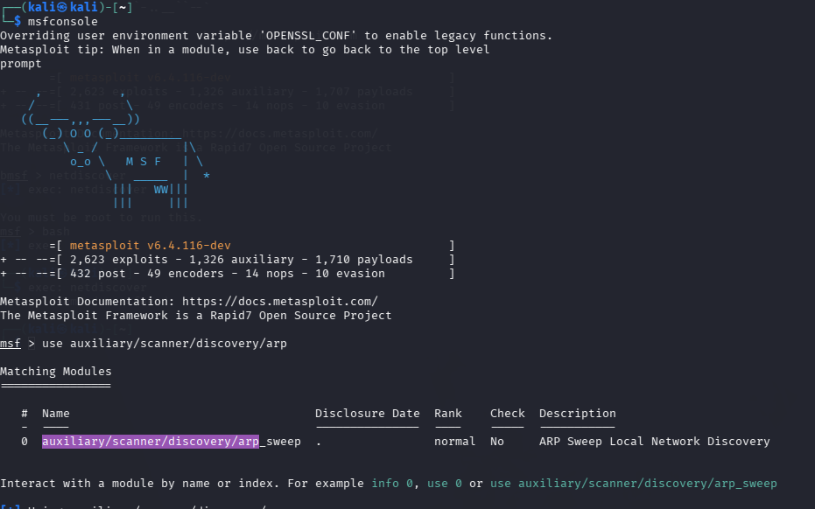
Figure 1: Nmap Host Discovery Results

Screenshot 2: Port Enumeration Results

Screenshot 3: Service Version Detection
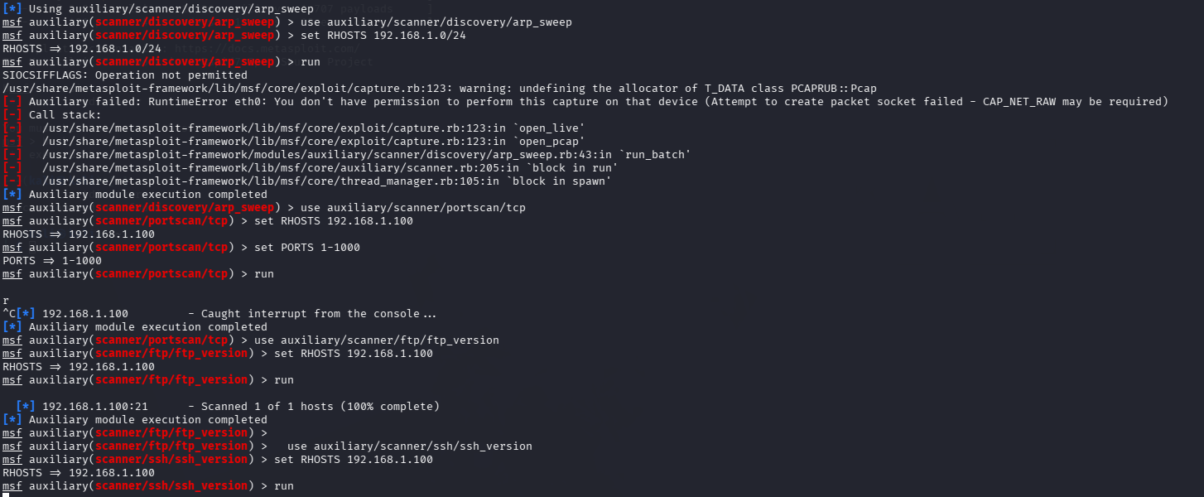
Figure 3: Service and Version Information

Metasploit Framework Scan Results
Metasploit Framework was used for additional reconnaissance and service enumeration.

Modules Used
- auxiliary/scanner/discovery/arp_sweep
- auxiliary/scanner/portscan/tcp
- auxiliary/scanner/http/http_version
- auxiliary/scanner/ssh/ssh_version
- auxiliary/scanner/ftp/ftp_version

Screenshot 4: Metasploit Host Discovery
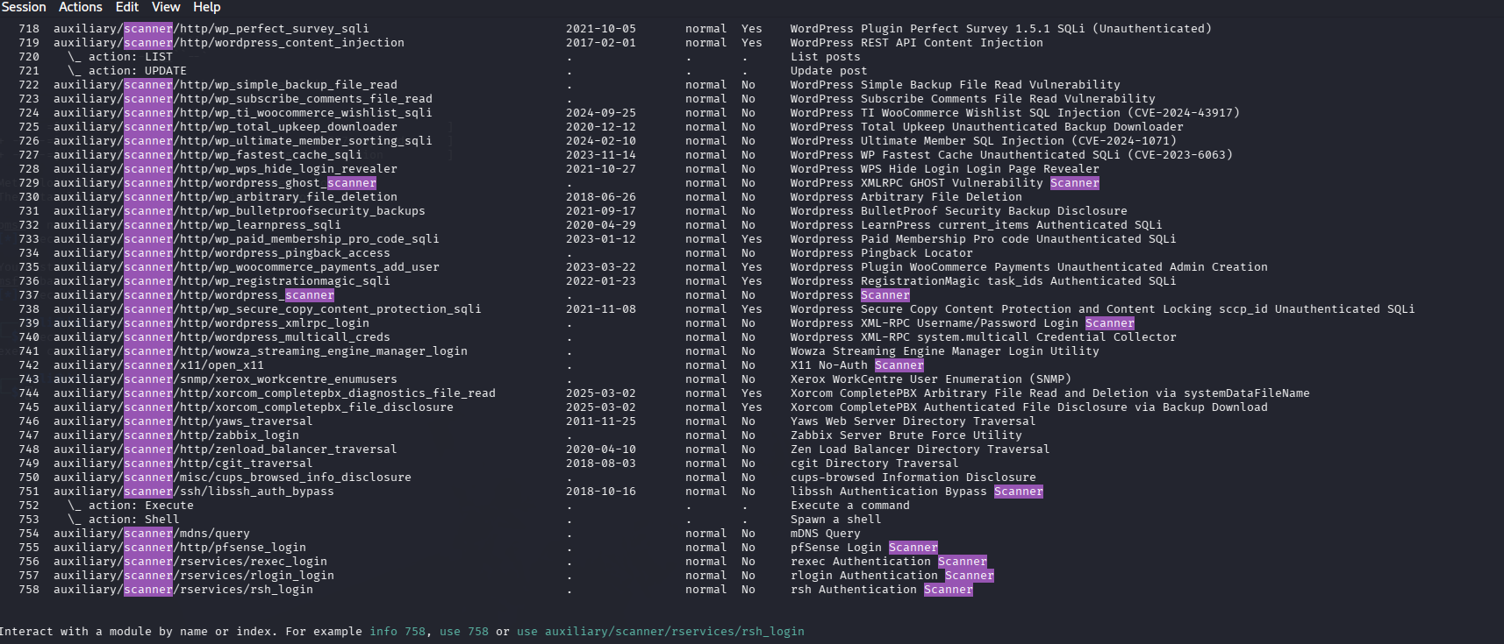
Figure 4: Host Discovery Using Metasploit

Screenshot 5: Metasploit Port Scan
Figure 6: Open Ports Identified Through Metasploit

Screenshot 6: Service Enumeration
Figure 6: Service Enumeration Results
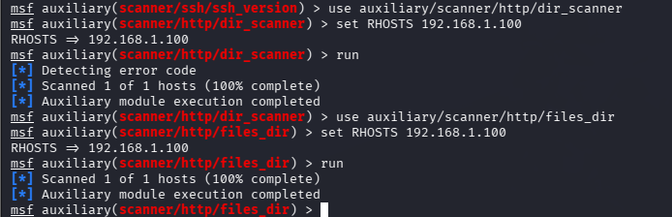

Nikto Vulnerability Scan Results
Nikto was used to perform web server vulnerability assessment.

Command Used
nikto -h http://

Screenshot 7: Nikto Scan Output
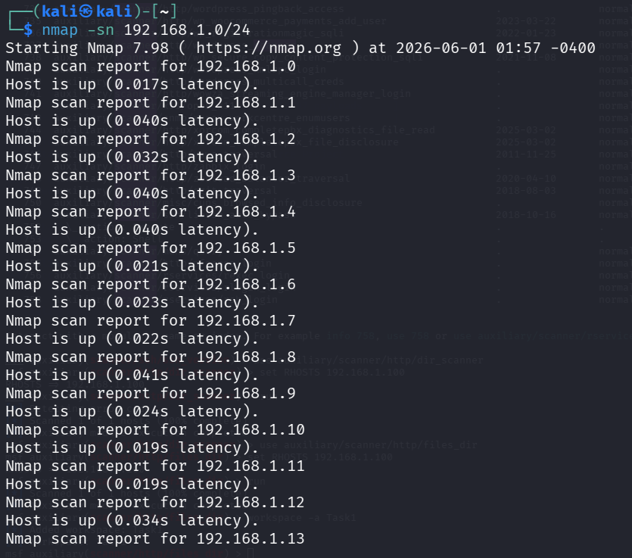Figure 7: Nikto Vulnerability Assessment Results

OpenVAS / Greenbone Vulnerability Assessment
OpenVAS was used to perform an in-depth vulnerability scan of the target system.

Screenshot 8: OpenVAS Dashboard
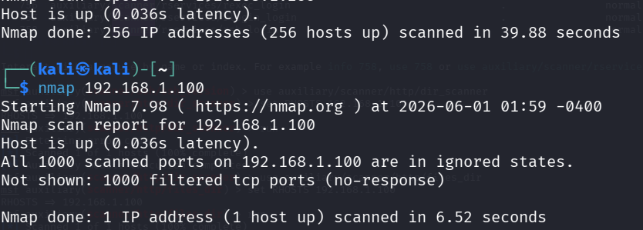Figure 8: OpenVAS Scan Dashboard

Screenshot 9: OpenVAS Vulnerability Results
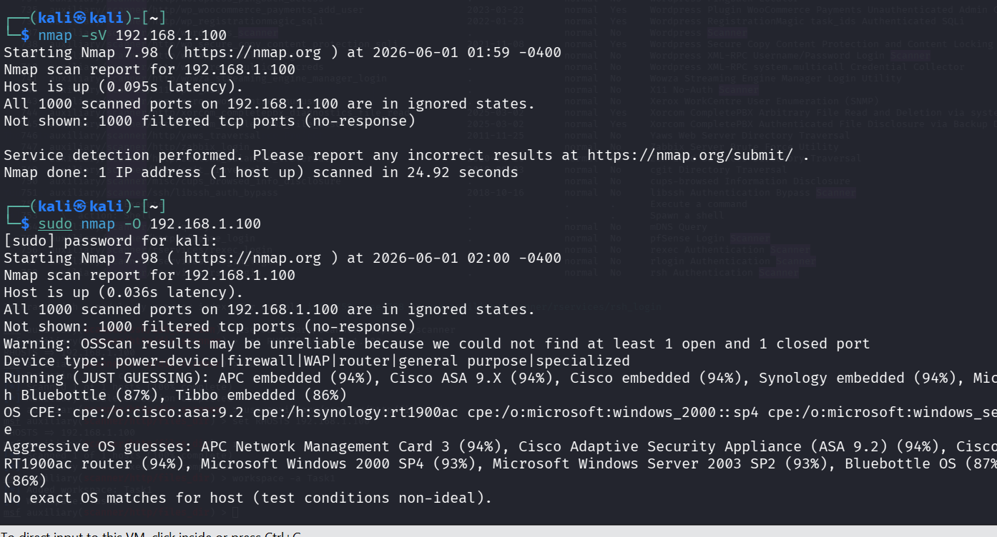Figure 9: Vulnerabilities Detected by OpenVAS

Findings
The reconnaissance and vulnerability assessment identified several exposed services and potential security weaknesses on the target system.
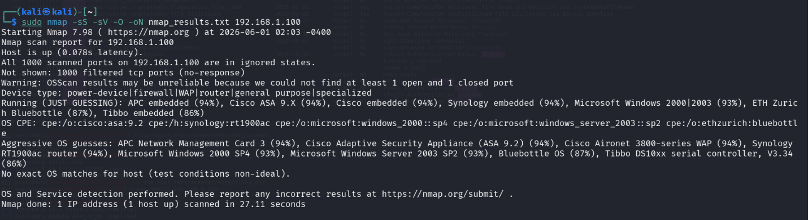

Open Ports Identified
Port | Service | Description
21 | FTP | File Transfer Protocol
22 | SSH | Secure Shell
80 | HTTP | Web Service
Other Ports | As Detected | Additional Services
(Note: Update the table according to your actual scan results.)

Services Detected
- FTP Service
- SSH Service
- HTTP Web Server
- Additional services identified during scanning

Vulnerabilities Identified

Vulnerability 1: Exposed Network Services
Risk Level: Medium
Description: Multiple services were accessible from the network, increasing the attack surface of the target system.
Recommendation: Disable unnecessary services and restrict network access.

Vulnerability 2: Outdated Software Components
Risk Level: High
Description: Service version detection indicated software versions that may contain known vulnerabilities.
Recommendation: Apply security updates and maintain a regular patch management process.

Vulnerability 3: Web Server Misconfigurations
Risk Level: Medium
Description: The web vulnerability assessment identified security weaknesses and configuration issues.
Recommendation: Review server configurations and implement recommended security controls.

Vulnerability 4: Information Disclosure
Risk Level: Low
Description: Certain service banners and server information were publicly accessible.
Recommendation: Disable unnecessary banner disclosures and reduce exposed information.

Risk Assessment
Finding | Risk Level
Exposed Services | Medium
Outdated Software | High
Web Misconfiguration | Medium
Information Disclosure | Low

Recommendations
- Regularly update operating systems and applications.
- Disable unnecessary network services.
- Restrict access using firewalls and access control policies.
- Implement strong authentication mechanisms.
- Conduct regular vulnerability assessments.
- Monitor systems for unusual activity.
- Remove or secure vulnerable applications and services.

Conclusion
The active reconnaissance and vulnerability assessment successfully identified active hosts, open ports, running services, and security weaknesses within the test environment. Nmap, Metasploit Framework, Nikto, and OpenVAS were utilized to gather information and assess the security posture of the target system. The findings highlight the importance of continuous monitoring, vulnerability management, and system hardening to reduce potential security risks.
The assessment achieved its objectives and provided valuable insight into the security status of the target environment.

References
- Nmap Documentation
- Metasploit Framework Documentation
- Nikto Documentation
- Greenbone/OpenVAS Documentation
- Kali Linux Documentation

